Healing Earth Life
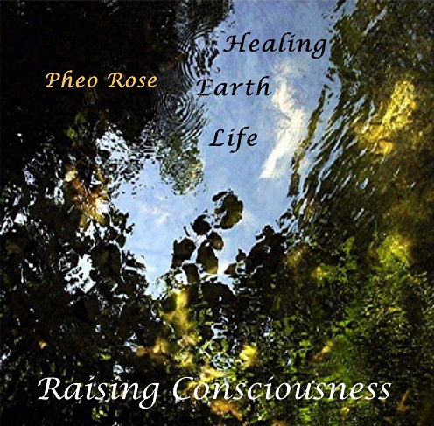

Healing Earth Life is a unique music cd that is based on the premise that each person is “one” with creation. Every molecule of our bodies has come from the earth and water of this planet. How we treat the planet directly affects not only the composition of our bodies, but the effects and consequences of how we treat this miraculous planet of earth and water. For too many thousand of years too many human cultures have often disregarded the condition of both the earth and waters. In the 21st century what is before us is not only integrated wellness for ourselves, but also restoring and promoting renewal resources and protecting non-renewable resources. Part of healing ourselves is to heal this earth that gives us life. The progression of music in this album progresses for musical expressions of the “plea” for human help, to responses, and a celebration of rejuvenation. The final piece, It is Time is a call to action. It is time that what is musically expressed is heard, responded to, and ultimately celebrated. Humanity can heal damage, but the focus needs to be on this during the 21st century. This music is inspired by the belief that as a listener deeply enters into these pieces their consciousness is raised: to the plea, the focus to heal, and the determination to create and follow values that will lead to the healing.
Help me is a plea of a life form that has lost what is needed to remain viable. The waters and the lands are filled with life which could be making this plea.
The Ocean’s Cry uses real whale vocalizations. The musical nuances render a “voice” of the ocean’s cry for not only human ravaging and pollution to cease, but also restoration and preservation be given.
Will You Wait? Denial delays. Acknowledgment without action delays. This piece of music is a plea to wait no more, it is a plea for human response.
Rays of Hope begins with the barrenness of a planet without vibrant and diverse forms of thriving life. With a human collective response “rays” of hope begin to stream in. Humans globally coordination with healing responses to life on earth takes a priority place. Materialism is replaced by “Earthism.” All life on this planet thrives, human and natural.
Genesis Dawn is the actualization of an immense global effort to restore and replenish the miraculous life on this planet. The “dawn” of earth life restoration honors both the global transformation of human consciousness” as well as the fruits that consciousness and effort will bring. The beginning of living realization of the interdependence between humanity and earth.
At_one_ment is a vital process which cannot be overlooked or missed – for really to feel a oneness with all that earth is a wondrous feeling of being truly alive.
Healing Waters is a metaphor for the human actions to restore, replenish, renew, clean, etc. the damage that has been done. And, also, to be proactive with climate changes and work with this. Human imagination, creativity, and thinking has what it takes. We just need to now use it.
Being Alive is when those feelings of being one with this earth are part of seeing the immense benefits of our actions, there is an increased integration of what it is to be alive.
Rejuvenation honors the efforts that will rejuvenate our miraculous planet of life. There is a myriad of pulsing rhythms to be restored; and, what a glorious sight and sound that will be.
It is Time summons humanity to begin the progression from hearing the earth’s plea with response to the human integration of interdependence. The lies that resources are limitless, and nature can hold whatever we discard are replaced by a consciousness that sees what is needed to maintain the interdependence. Humanity can promotion earth life, as earth life then can sustain human life.

